**11. SONOMETER**

**Objective**: To determine the frequency of AC mains using Sonometer.

**Apparatus Used**: Sonometer with metallic wire, Inbuilt AC supply, electromagnet, meter scale, slotted half kg weights, two Knife edges.

**Theory and Formula Used**:

A **Sonometer** is a device which consists of a thin wire stretched over two bridges that are usually mounted on a soundboard and which is used to measure the vibration frequency, tension, density, or diameter of the wire, or to verify relations between these quantities.

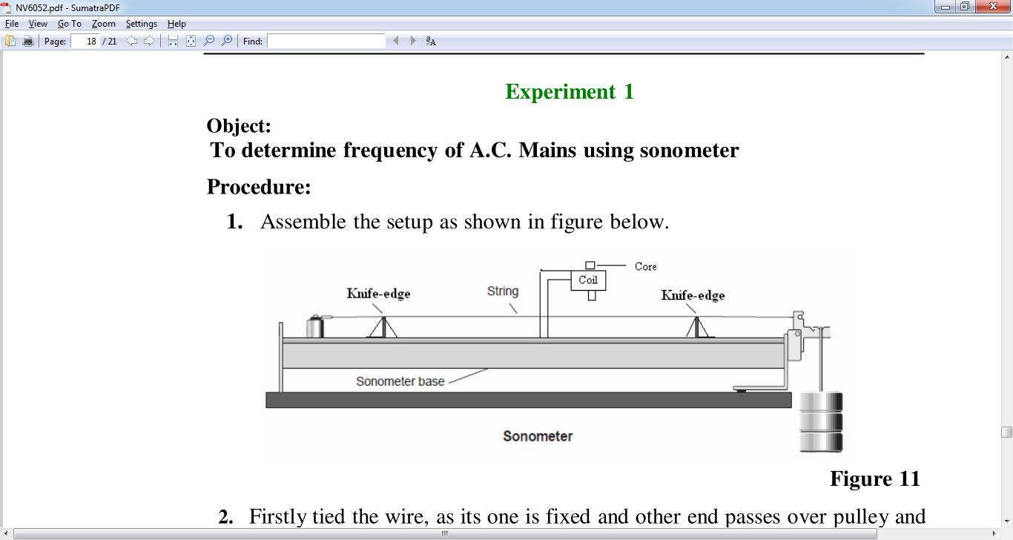

**Electromagnet**:

An electromagnet is a type of magnet in which the magnetic field is produced by the flow of electric current. The magnetic field disappears when the current ceases. A wire with an electric current passing through it generates a magnetic field around it of strength proportional to the amount of current. The main advantage of an electromagnet over a permanent magnet is that the magnetic field can be rapidly manipulated over a wide range by controlling the amount of electric current. However, a continuous supply of electrical energy is required to maintain the field.

**Frequency of AC mains:**

The utility frequency or mains frequency is the frequency at which alternating current (AC) is transmitted from a power plant to the end user.

To find the frequency of AC Mains using an electro-magnet and a sonometer, the AC is passed through the primary of a step-down transformer (220-230 to 4-6 volts).The two ends of the secondary coil of the step-down transformer are connected to the two ends of the windings of the electro-magnet which consists of a coil of insulated copper wire wound over a soft iron core provided with an insulated handle. As the A.C. From the secondary of the step- down transformer passes through the electro-magnet it gets magnetized twice in each cycle, first with one of its faces as a north pole and then with the same face as the south pole. The electro-magnet is kept close to and vertically above the sonometer steel wire. The wire is attracted and pulled twice in each cycle of the A.C. Mains supply; once when the end of the electromagnet just above the wire is a north pole and again after half a cycle when this end is a south pole. In other words, the natural frequency (*f*) of the sonometer wire is double the frequency (*n*) of the A.C. Mains. The natural frequency of the wire is given by



where,

*l*=length of the sonometer wire between two knife edges when it is thrown into resonant vibrations

*T*=tension in the wire

*m*=mass per unit length of the wire.

The frequency of the ac mains is given by



**Procedure:**

1. Assemble the setup as shown in the figure.

2. Firstly tie the wire, as its one end fixed and other end passing over pulley carrying a hanger of weights.

3. Mount the L-clamp of coil with the screws of sonometer base at a distance 2-3 mm above the wire.

4. The core of electromagnet should lie at the center of coil.

5. Now connect mains cord between mains and sonometer.

6. Take two patch cords from the accessory box and connect the 6 V AC supply from sonometer to the coil with polarity.

7. Now hang the weight of 1000 gms to the hanger connected with one end of steel wire.

8. Switch on the AC supply.

9. Now adjust two knife edges by slowly increasing the distance between them so that you get some vibrations in wire.

10. Now slowly adjust both knife edges for maximum vibration in the wire.

11. Note the length (*l1*) of wire between two knife edges by given meter scale.

12. Also note load (W) in kg (including the weight of hanger).

13. Now increase load by 500 gms and again get the position of maximum vibration by adjusting both knife edges.

14. Again note the length (*l1*) of wire between two knife edges for the increased load.

15. Repeat the same procedure by increasing weight by 500 gms and take reading of *l1* for maximum vibration.

16. Note all values in observation table below

17. Repeat the steps 7to15, adjusting two knife edges by slowly decreasing the distance between them so that you get maximum vibrations in wire for every observation.

18. Note the values of length *l2* for respective loads and compute mean length, *l*.

**Observations**:

Mass per unit length of the wire (*m*) = 0.0056 kg/m

|  |  |  |  |  |  |  |
| --- | --- | --- | --- | --- | --- | --- |
| S.No | Load in kg  (W) | Tension in Newton  T= (W×9.8) | Resonating length of the wire (cm) | | | Frequency $$f=\frac{1}{2l}\sqrt{\frac{T}{m}}$$ (Hz) |
| *Position of bridges increasing* (*l1*) | *Position of bridges decreasing* (*l2*) | *Mean resonating*  *length*  (*l*) |
| 1. |  |  |  |  |  |  |
| 2. |  |  |  |  |  |  |
| 3. |  |  |  |  |  |  |
| 4. |  |  |  |  |  |  |

Mean f=…..Hz

**Calculations:**

Using the formula

**

Compute frequency of vibration of the wire for each observation and find out the mean frequency.

The frequency of ac mains is given by



**Result**: The frequency of AC mains=………..Hz.

Standard result: The frequency of AC mains = 50 Hz.

**Percentage error**:



= …….%

Standard value for frequency of ac mains = 50 Hz

**Precautions and sources of error:**

(i) The wire should be of a uniform area of cross-section, free from kinks and should be tight.  
(ii) The observation should start with minimum distance between the two Knife edges.  
(iii)The resonance position should be obtained by first slowly increasing the distance between knife edges and then slowly decreasing it.  
(iv)The weight of hanger should always be included in the load.  
(v) The pulley should be free from friction.  
(vi)The electromagnet should be clamped 2-3 mm vertically above the center of the sonometer wire.